Tips for managing your StoryStarter Sets
- Number your sets and assign students to the sets. Let them be responsible for their sets. Bringing them out, putting them away, etc.
- Number the plastic top, tray’s inside and top card with the same “box number”
- Your box number should be on all 4 sides of the box so when they are placed on the shelf you can see the number of the kit from all sides.
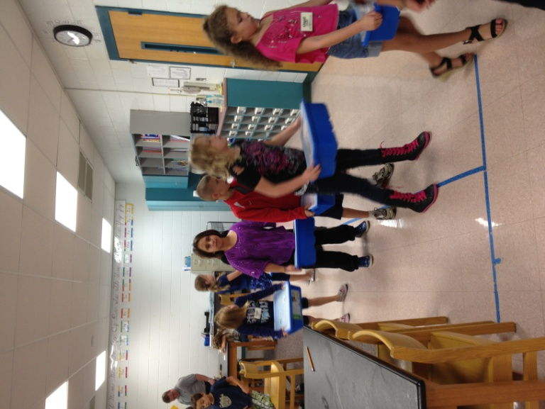
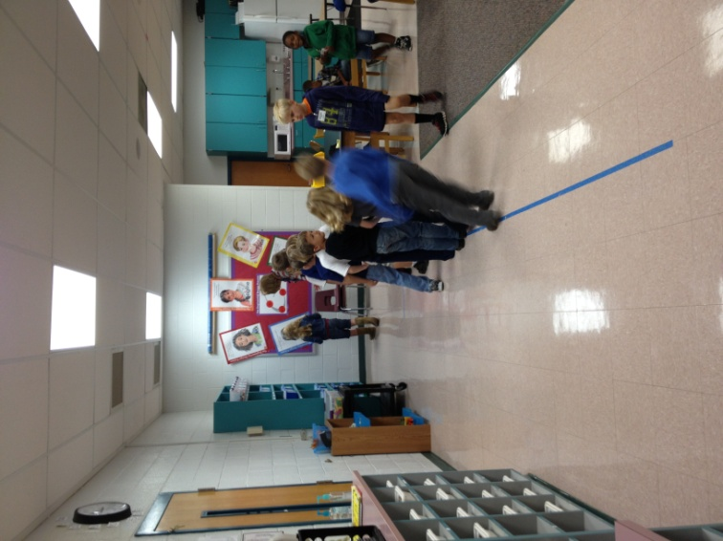

- Let students take inventory of the sets the first time around. Use the inventory sheets found on the StoryStarter Edmodo page.
- Consider a paint pen to color the rim of the compartments of the trays. It is more permanent than the stickers around the edges.
- Use a bath towel for building. Provides a common place for building in larger groups, keep all parts on the towel. It also keeps parts from skidding off desktops.
- Develop Story Board pages or diagram document of some sort for students to take notes on their story after they have built it. Students will be able to take these notes with them to the computer lab for use when creating documents in the StoryVisualizer software.
- Consider some basic classroom rules for example
  - If you drop it – pick it up.
  - Do not take or borrow parts from other kits.
  - If there is a part you need that you don’t have, it is ok, just use a different piece and explain what it represents.
- Keep a box at the front of the room for “Lost Parts”. Lost parts do not go in your kit if you find one. They go in the Lost Parts Box. You are allowed to retrieve a lost part only if it is verified by the teacher that yours is missing.

